**Q1. From the following balances extracted from the book of Alfa traders as on  
 31st March 2016, prepare the final accounts of the concern.**

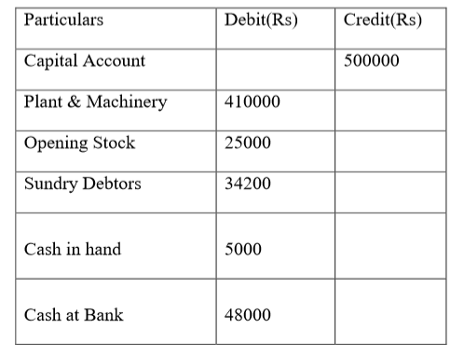

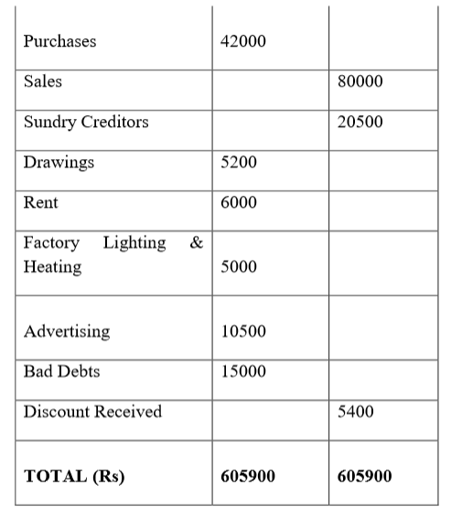

**The following adjustments are to be made:**

1. **Closing Stock Rs.50600**
2. **Rent due but not paid upto 31st March 2016 Rs.500**
3. **Advertisement paid in advance Rs. 2000**
4. **Depreciate plant & machinery by 10%, furniture by 5% .**
5. **Write off further bad debts Rs.500**

**Ans.**

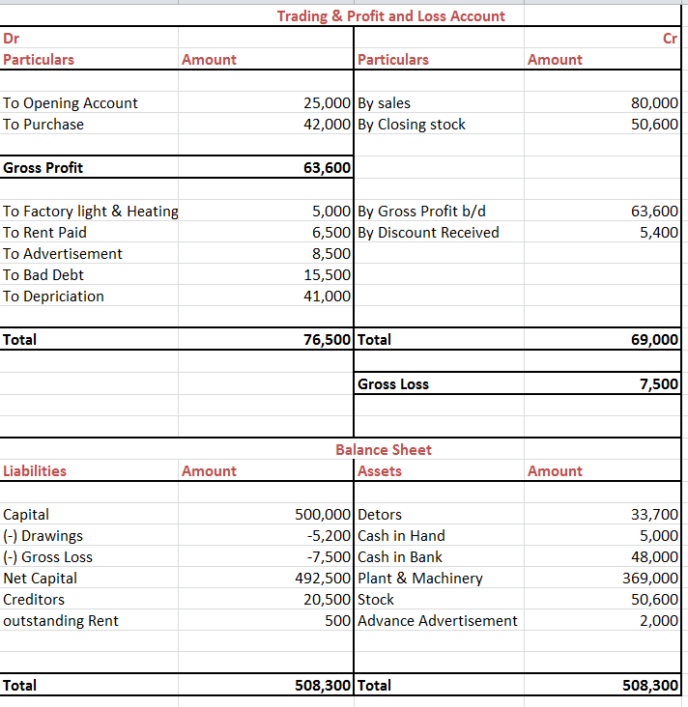

**Q2. Mr. James & Mr. Jiggar are the directors of Balajii Auto Pvt Limited. They want to make certain strategic decisions and to implement certain controls within the company. Meeting of all BOD’s is called. Mr. Ajay being the accounts executive of the company keeps the audited financial statements ready following all the essentials of financial accounting. Mr. Ajay was about to present the audited financial statement in the management’s meeting but his senior colleague suggests him that in such a meeting he should present projected statements as well as all other such reports which the management needs, as management accounting is differ from financial accounting. Discuss who is correct Mr. Ajay or his senior colleague and why? Explain the same in detail.**

**Ans.**

The suggestion given by Mr. Ajay’s senior colleague is right and genuine as the aim of meeting is to make certain strategic decisions and to implement certain controls within the company. In context to the meeting managerial statements are required which caters management by providing information that is used to plan, set goals and evaluate desired goals.

Differences in Financial Vs Managerial accounting are:

|  |  |
| --- | --- |
| **Financial Accounting** | **Managerial Accounting** |
| Financial Accounting is an accounting system that focuses on the preparation of financial statement of an organization to provide the financial information to the interested parties. | The accounting system which provides relevant information to the managers to make policies, plans and strategies for running the business effectively is known as Management Accounting. |
| Financial Statements are prepared at the end of the accounting period which is usually one year. | The reports are prepared as per the need and requirements of the organization. |
| Rules in financial accounting are prescribed by standards such as GAAP or IFRS. There are legal requirements for companies to follow financial accounting standards. | Managerial accounting reports are only used internally within the organization; so they are not subject to the legal requirements that financial accounts are. |
| Monetary, verifiable information. | Monetary and company goal driven information. |

Management Accounting is the process of identification, measurement, accumulation, analysis, preparation, interpretation, and communication of information that used by management to plan, evaluate, and control within an entity and to assure appropriate use of an accountability for its resources.

Whereas, financial accounting is concerned with providing information to stockholders, creditors, and others who are outside an organization. Managerial accounting provides the essential data with which organizations are actually run. Financial accounting provides the scorecard by which a company’s past performance is judged.

**Q3. a)**

**Aditya Ltd is a FMCG company. The company is about to start a new line of**

**production and is supposed to close its one of its production unit. The following**

**information about Aditya ltd is provided. Installed a new plant worth 500 lacs, however paid only 450 lacs for the same. The company spent 50 lacs for the construction of new shed, one of the machinery acquired in the 2005, at a cost of 85 lacs having written down value of 25 lacs as on date is sold at a profit of 10 Lacs .The company also paid interest on debentures, being the source of capital Rs10 lacs. It also acquired 5 % shares of Birla ltd at a value of 50 Lacs and received Rs 25 lacs on account of maturity of one of the saving bonds. Calculate the net cash flow from investing activities.**

**Ans.**

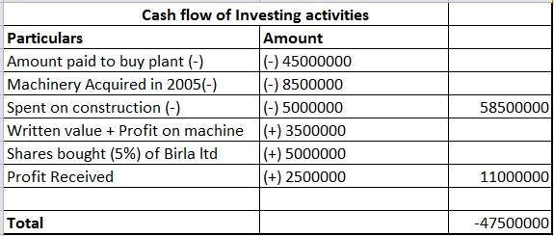

**b)**

**The Balance Sheet of XY Ltd is as under**

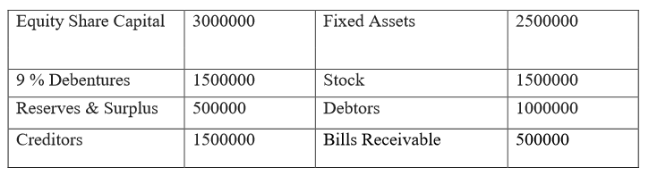

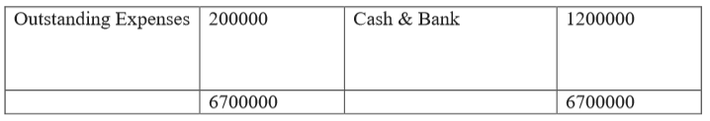

**Calculate the following**

1. **Current ratio**
2. **Liquid ratio**
3. **Solvency ratio**

**Ans.**

Current Ratio: Current Assets / Current Liabilities

current assets = 1,000,000(debtors) + 1,200,000(cash) + 1,500,000(stock) +  
 500,000(bills receivable)

current liabilities = 1,500,000(creditors) + 200,000(outstanding expenses)

Current asset = 4,200,000

Current liabilities = 4,700,000

Current ratio = 2.47

Liquid Ratio: Liquid assets / current Liabilities

Liquid asset = 4,200,000(current assets) - 1,500,000(stock)

Current liabilities = 4,700,000

Liquid asset = 2,700,000

Liquid ratio = 1.59

Solvency Ratio:

1. Debt to equity ratio

Debt: 1500000

Equity: 3000000(share capital) + 500000(reserves) => 3500000

Debt to equity = .43

b) Debt to Asset ratio

Total debt = 1500000

Total asset = 3200000

Debt to asset ratio: .46875